**Electronic supplementary information**

**HYBRID COMPOSITES BASED ON CHITOSAN MODIFIED BY CONJUGATES OF Ag AND Cu NANOPARTICLES  
WITH DIHYDROQUERCETIN**

P. R. Voloshina,\**a,b* А. N. Tretyakova,*a,c* А. S. Golub,*a* and А. Yu. Vasil'kov*a*

*a Nesmeyanov Institute of Organoelement Compounds, Russian Academy of Sciences,  
ul. Vavilova 28, str. 1, Moscow, 119334 Russia*

*b* Mendeleev University of Chemical Technology of Russia,  
Miusskaya pl. 9, Moscow, 125047 Russia

c Moscow Institute of Physics and Technology (National Research University),  
Institutskiy per. 9, Dolgoprudny, Moscow Region, 141700 Russia

**1. Materials and methods**

**1.1. Materials**

Chemical reagents and media used in work: silver (purity 99.99%), isopropanol (Fluka, Buchs, Switzerland, 99.8%), copper (purity 99.99%), toluene (Komponent-Reaktiv, Russia, 99,5% ), chitosan (Wirud C100001, GmbH", Kaiser-Friedrich-Promenade 2, D-61348 Bad Homburg v.d.H.), dihydroquercetin (BCMST, Moscow, Russia, purity 98.5%).

**Modification of chitosan by silver and copper nanoparticles obtained by the metal-vapor synthesis.** The MVS was carried out by the co-condensation of vapors of metal (0.3 g of Ag) and organic reagents (120 mL of isopropanol) under vacuum of 10–2 Pa on the walls of a 5 L quartz reactor cooled to –196 °C. The metal was evaporated by resistive heating from a tantalum evaporator (90 × 5 mm). After the completion of metal evaporation, the supply of the organic reagent was stopped. The cooling was removed, and the co-condensate was heated until melting. Then the matrix was defrosted, the organosol was removed from the reactor through a siphon system into a prepared evacuated flask containing a solution of dihydroquercetin in isopropanol. This procedure was carried out for 60 min. During the *in situ* application, the reaction mixture was stirred with a magnetic stirrer and the flask was filled with argon. Then the flask was disconnected from the siphon line, and the mixture was stirred for 60 min. This solution was added to the evacuated flask containing a chitosan powder, and the resulting mixture was stirred for 60 min.

At the end of the deposition process, the metal-containing matrix was decanted from the organic solvent and dried under vacuum (10–1 Pa) at 60 °C to constant mass. The distillation from the solvent gel under vacuum afforded the target sample.

**1.2. Methods**

**Scanning electron microscopy** was conducted using a JCM-6000 PLUS microscope equipped with an energy-dispersive spectrometer, operating at accelerating voltages ranging from 5 to 15 kV.

**Powder X-ray diffraction analysis** was performed with a D8 Advance (Bruker AXS, Karlsruhe, Germany) diffractometer in the Bragg–Brentano focusing geometry using CuKα radiation and an angular range of 5–90° with a step of 0.02° and the scan rate of 0.5–2.0 deg min–1. The samples were placed on flat holders. The diffraction pattern profiles were fit using the TOPAS 5 program package (Bruker AXS).

**The antibacterial activity** of the resulting hybrid samples was assessed using two bacterial strains, namely, *Escherichia coli* (ATCC 25922) and *Bacillus cereus* (ATCC 11778), which were grown in Mueller–Hinton broth (Merck KGaA, Darmstadt, Germany) at 37 °C. The minimum inhibitory concentrations (MICs) of the hybrid nanocomposites were determined using the liquid serial dilution method. In brief, all samples were diluted two-fold starting from a concentration of 20 mg/mL to a final dilution step yielding a 0.02 mg/mL solution. 100 μL of all sample dilutions were transferred to a 96-well plate and then 100 μL of bacterial suspension was added to all test wells, establishing a culture with the initial concentration of 1 × 106 cfu/mL. Hence, the test concentrations of the samples explored were 10, 5, 2.5, 1.25, 0.625, 0.31, 0.16, 0.08, 0.04, 0.02, and 0.01 mg/mL. In addition, three types of controls were used: 100 μL sample and 100 μL culture medium (without bacterial cells); 100 μL culture medium and 100 μL bacterial suspension (control without test-sample), and an antibiotic control (streptomycin/penicillin) which was assessed using the following serial dilutions 100/100, 50/50, 25/25, 12.5/12.5, 6.25/6.25, 3.12/3.12, 1.56/1.56, 0.8/0.8, 0.4/0.4, 0.2/0.2, 0.1/0.1 µg/mL streptomycin/IU penicillin. The culture plates were incubated overnight at 37 °C. Then 3-(4,5-dimethylthiazol-2-yl)-2,4-diphenyltetrazolium bromide (MTT) (Merck KGaA, Darmstadt, Germany) (5 mg/mL) was dissolved in Dulbecco's phosphate buffered saline (DPBS) (Merck KGaA, Darmstadt, Germany) and 20 µL/well MTT solution were added to each well. In the sample wells with growing and metabolically active bacteria, the yellow tetrazolium salt MTT can be reduced, yielding a purple-colored formazan product. The culture plates were incubated for up to 1 h at 37 °C, and after that the absorbance at 570 nm was measured using SpectraMax i3x spectrophotometer (Molecular devices, San Jose, CA, USA). The lowest test-concentration of a sample that inhibited the bacterial growth after overnight incubation under standard conditions was defined as the MIC.

**Transmission electron microscopy** was performed on a LEO 912AB OMEGA device (Zeiss, Germany) at an accelerating voltage of 100 kV. For analysis, the samples were pre-crushed in an agate mortar, suspended in ethanol and dispersed by ultrasound for 10–15 min. Then a small amount was placed on a formvar/carbon mesh. The particle size distribution of the samples was calculated by measuring the size of 200 displayed particles using the SigmaScan Pro software.

2. Results and discussion

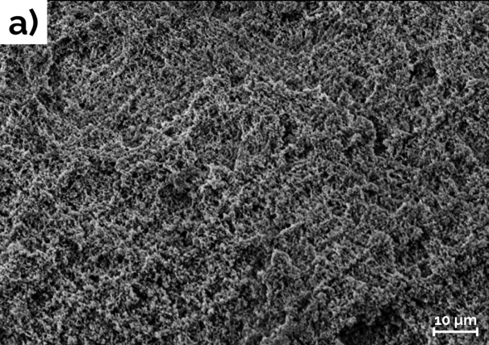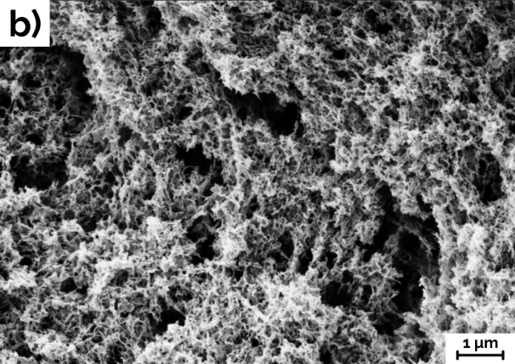

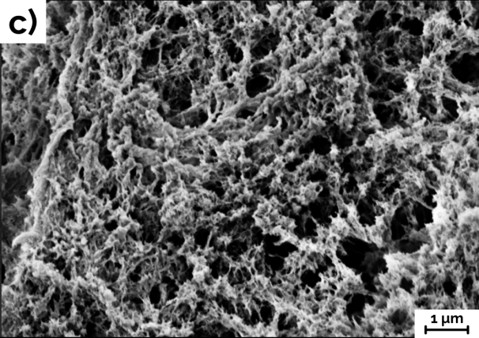

**Figure S1.** SEM images of Chit (***a***), Chit-CuNPs (***b***), Chit-AgNPs (***c***).

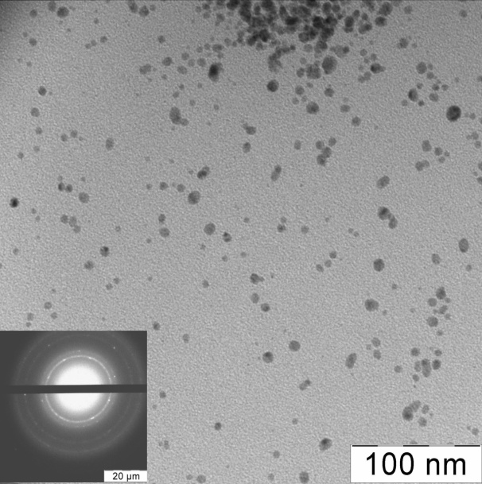 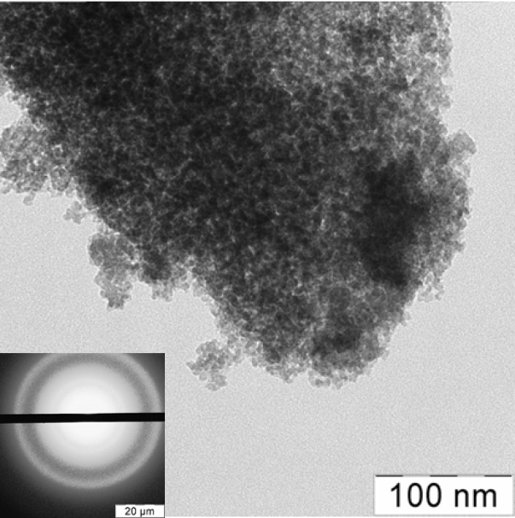

a

b

**Figure S2. TEM micrographs of Ag nanoparticles on a light background (electron diffraction in the lower left corner) (*a*), Cu nanoparticles on a light background (electron diffraction in the lower left corner) (*b*).**



**Figure S3.** Powder X-ray diffraction patterns of Chit (**1**) and Chit-CuNPs (**2**).